User Manual

FPV GOGGLES

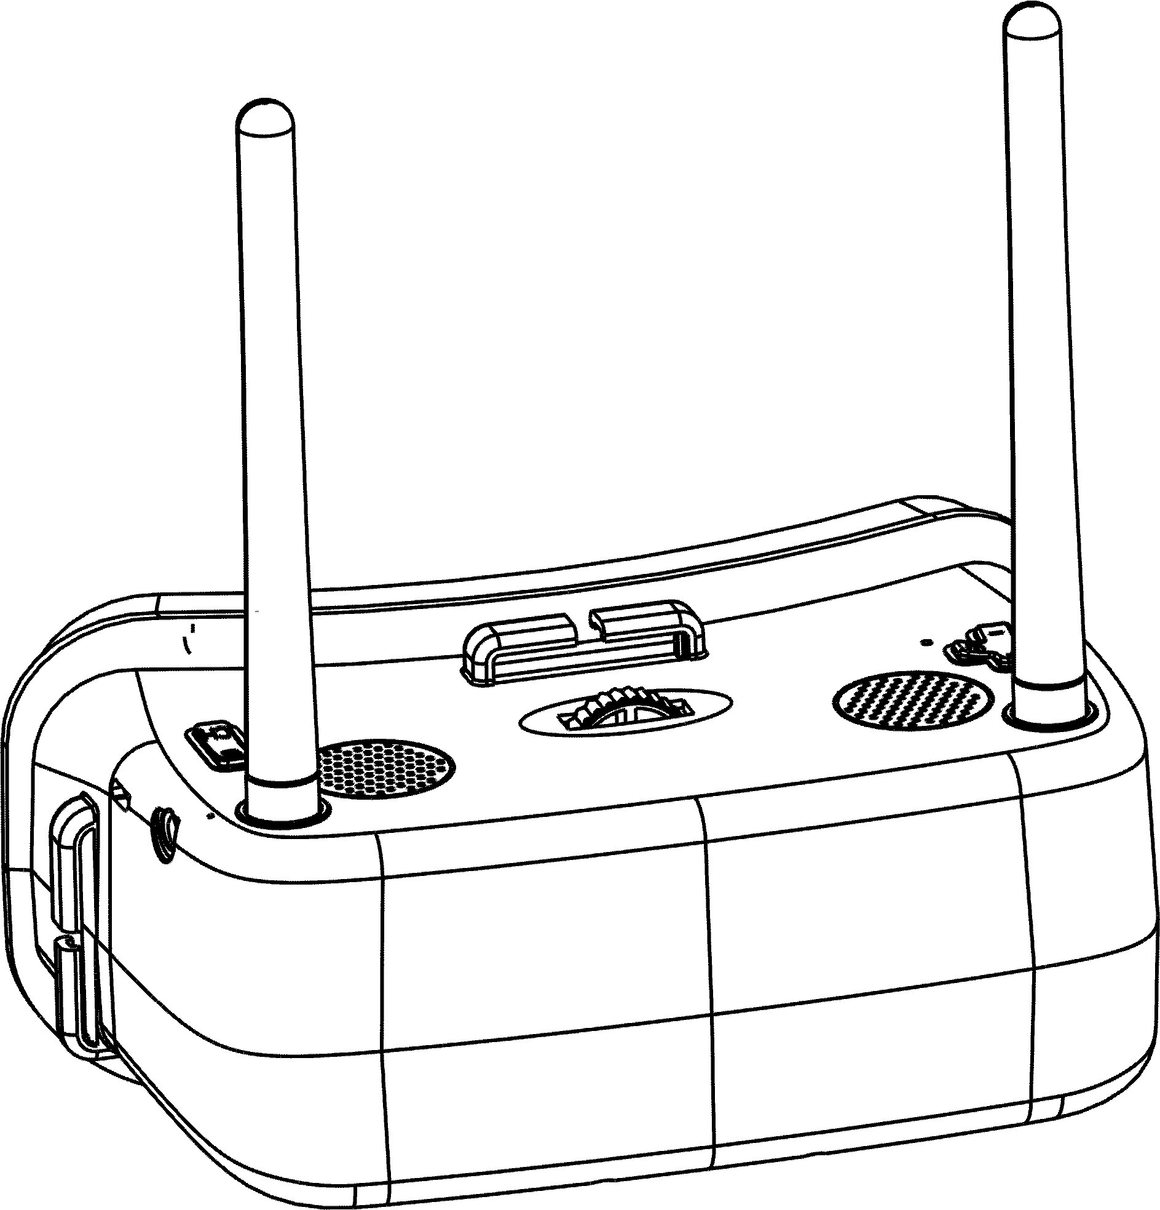
EW 30

Function Introduction

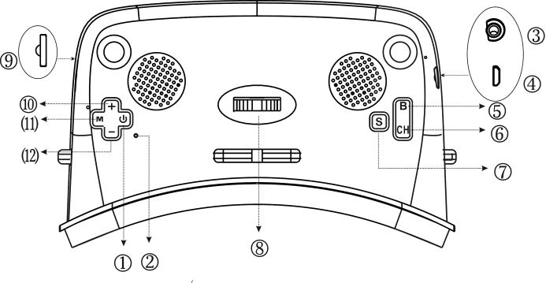
Item | Definition | Operation method & application
① | Power key | Long press 3 seconds, on/off
② | Reset key | If it could not be powered off by the power key after system stopped working by mistake, you can press reset key, to force the system to be powered off.
③ | AV IN | System would be switched automatically into AV mode after external AV equipment; and would be switched into 5.8G mode after pull out AV equipment.
④ | USB | External DC5V power charge.
⑤ | B Key | To press A,B,C,D,E,F band to switch when using 5.8G mode.  To press “+” for increasing when using setting menu.
⑥ | CH Key | Press “S” Key to switch from channel 1 to channel 8 when using 5.8G mode.  To press “S” key for decreasing when using setting menu.
⑦ | S Key | To press for setting menu, and continue press to switch to the next menu.  Automatically search by long pressing “S” key.
⑧ | Interpupilary distance(IPD) | 60 to 68mm(Adjustable).
⑨ | TF card slot | Maximum support 32G TF card
⑩ | “+” Key | Press for video record, and press again for stop.  To press “+”for amplify when using video setting menu.
⑪ | Mkey | Long press 3 seconds to start video setting and press again to quit.  To press for ok when using setting menu.
⑫ | "-"Key | To press 3 seconds to start video replay, and can choose the video content by pressing “+” and “-“key.  To press “-“ for decreasing when using setting menu.
Operation introduction
1. S Automatically channel search
The device would search signal one by one according 48 channels by pressing “Automatically channel search”. The device would stop searching when it searched the signal. User can press “Automatically search” key to continue if the signal is not required.

2. AV 3.5mm AV input

3. B …Bands
To press “B” key to exchange from “A,B,C,D,E,F” band when using manual bands searching.

- CH… Channels
After setting up bands by pressing “B” key when using manual bands searching, it would be exchanged from 8 channels by pressing “S” key continuously.

- Video and replay
To press “+” key to start video record and to press again to stop.
Long press “-“to choose the video which is recorded, to press “M” for replay.

5.1 Setting
Brightness
- 0……………100 +

Contrast

- 0……………100 +

Sett
ing
- 0……………100 +
Chroma

- 0……………100 +
Tinge
15 languages by pressing”+”/”-“
Languages

Pressing “+”/"-"
Reset

5.2 Video setting
HD
D1
SIZE
VGA
HD
HD
Off
Time
On
HD
HD
Setting
HD
1 Min
Video
3 Min
HD
HD
5 Min
On
Auto
Off
2019/01/03 11:54
Date Input

Specification parameters
Screen |  |  | 2 inch TFT LCD 480*360 pix *2 display,300cd/㎡
Lens |  |  | FOV:120°, Magnification: 3.5X, Material: PMMA, Distortion: No, Vitreousness: >93%
Battery |  |  | 3.7v 1000mAh Li-ion
Consumption |  |  | 3.7V/400-600mAh. 1.5W-2.2W
Frequency |  |  | 5.8GHz,48CH
Ports |  |  | 3.5mm AV in, Micro USB(Support DC5V power charge),TF card and up to 32 Gb
IPD |  |  | 60-68mm(Adjustable)
Working temperature |  |  | -10℃-50℃
Storage temperature |  |  | -20℃-90℃
Weight |  |  | 200g
Dimension |  |  | 152mmX92mmX70mm
Band | CH1 | CH2 |  | CH3 | CH4 | CH5 | CH6 | CH7 | CH8
Band-A | 5645 | 5665 |  | 5685 | 5705 | 5885 | 5905 | 5925 | 5945
Band-B | 5740 | 5760 |  | 5780 | 5800 | 5820 | 5840 | 5860 | 5880
Band-C | 5725 | 5745 |  | 5765 | 5785 | 5805 | 5825 | 5845 | 5865
Band-D | 5733 | 5752 |  | 5771 | 5790 | 5809 | 5828 | 5847 | 5866
Band-E | 5658 | 5695 |  | 5732 | 5769 | 5806 | 5843 | 5880 | 5917
Band-F | 5362 | 5399 |  | 5436 | 5473 | 5510 | 5547 | 5584 | 5621

